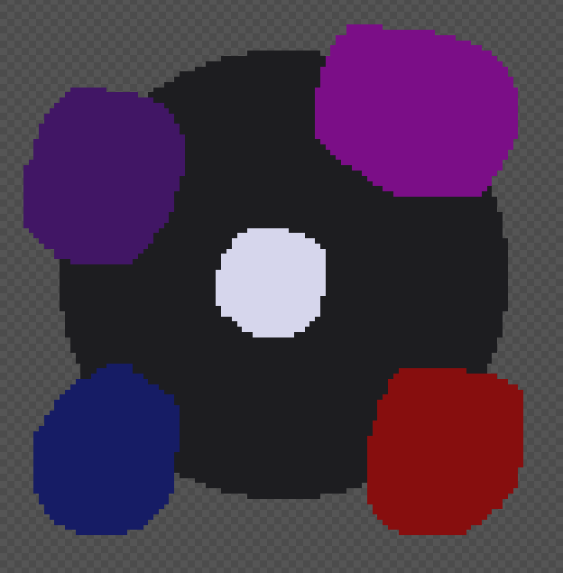

Void Black - 1d1d20

Stardust White - d6d6ec

Jellyfish Purple – 411665

Hydrogen Magenta - 7b0e87

Primordial Blue - 161c65

Red Giant - 870e0e

This palette is full of intense hues that would work well together to make a detailed galaxy sky or other art piece. Its space and science themed, with Void Black being the void between stars, Stardust White being the pinpoint light of distant stars, Jellyfish Purple is based on the Jellyfish Star which is purple, Hydrogen Magenta being a good color for gas clouds as well as Primordial Blue, and Red Giant being the color of dying stars.



Stormy Sky Blue - 65889c

Thunderhead Grey - 50595e

Silver Horizon - 83898d

Inky Sea Blue – 253640

Reflective Blue - 91b1c3

Shadows Below Blue - 91b1c3

This palette is a monochrome stormy sea palette, creating an air of trouble or warning. The sun is gone, the sky is crying, and the sea is very, very angry. This palette is suitable for backgrounds.

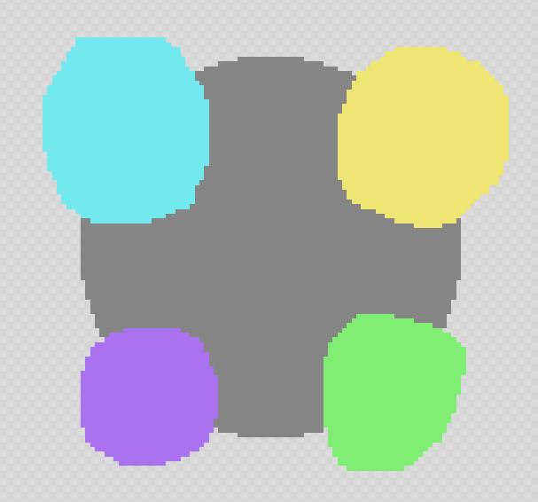

Steel (grey) - 858585

Memories of the Sky (Blue) - 72e9ee

Spotlights (Yellow) - eee572

There’s No Healing in Wonderland (purple) - aa72ee

Greed (green) - 7fee72

This palette is loosely inspired by the Wonderland arc of the podcast The Adventure Zone. Wonderland is a gaudy, vibrant, headache-inducing place full of bright colors and things that want to kill you. This palette is purposefully bright and somewhat clashes, but the tone for all the colors is the same. The Wonderland palette would be good for setting a chaotic scene.

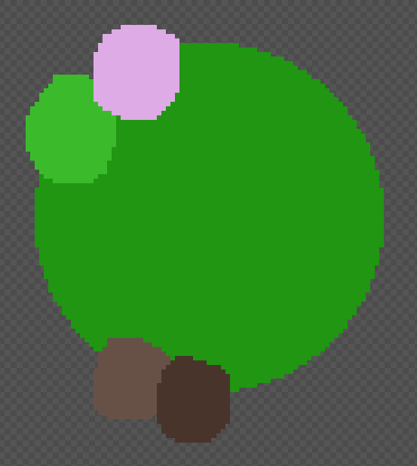

Leaf Green – 209613

Light through the Canopy (lighter green) - 3bbb2c

Spring Blossoms - deabe7

Tree Trunks – 675147

Other Tree Trunks – 675147

This palette is a warm spring forest palette. Everything is in bloom, lush, and beautiful. The Spring palette is good for foliage.

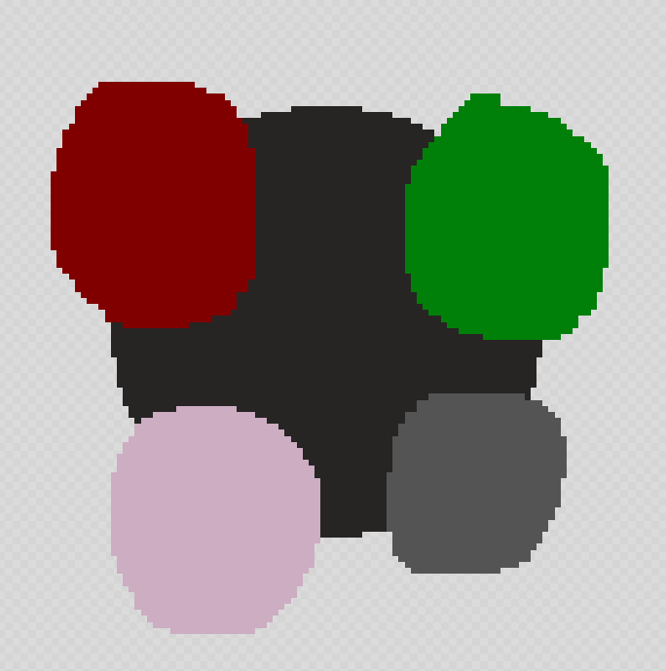

Spades (black) – 272424

Hearts (red) – 800000

Diamonds (pink) - ccadc2

Clubs (grey) – 545454

Felt (green) – 008009

The Midnight Crew is a muted palette suitable for making backgrounds, perhaps for a club or alleyway. It has a few colors that pop a little, but they’re muted enough that if used correctly they can fade into the background.